Maths Key Skills Stage 6: Skill Check 8

Name: ___________________________________ Date: _______________ Class/Group: _______________________________

A: Place Value, Add, Subtract, Multiply and Divide |  | B: Fractions, Ratio, Proportion and Algebra |  |  | C: Measure, Geometry and Statistics
1. Write one million, six hundred and sixteen thousand, and ten in digits. | 6:1 | 11. Which is the  1  6  3  12  5  24  or  ,  smallest fraction? |  | 6:7 | 21. Calculate the  3cm  area of this triangle.  18cm |  | 6:21
2. What is the value of the 4 in this number? 3,954,682 | 6:1 | 12.  7  12  3  8  +  = |  | 6:8 | 22. Find the volume  3m  2m  of this cuboid.  5.5m |  | 6:22
3. Round 4.953 to 1 decimal place. | 6:1 | 13. Simplify  6  7  3  8  x  =  your answer. |  | 6:9 | 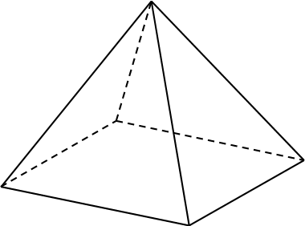  23. Complete the  information for  this shape:  Faces = Edges = Vertices = |  | 6:23
4. Write the smallest possible length.  Length: 9.15cm (to 2 decimal places) | 6:2 | 14. 8.373 x 100 |  | 6:10 |  |  | 6:23
5. 1,914 x 33 | 6:3 | 15. 7.88 x 4 |  | 6:11 | 24. Use this table to complete the pie chart to show fruits sold by a shop.  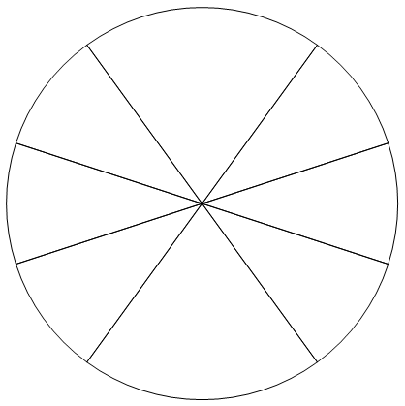 |  | 6:29
  Fruit | No. sold
  Apple | 15
  Banana | 25
  Orange | 10
6. Give the answer as a mixed number: 3,396 ÷ 16 | 6:3 | 16. Write this decimal as  0.75  a fraction and a percentage. |  | 6:12 |  |  | 6:29
7. Which is a common multiple of 9 and 15? 30 45 54 60 75 | 6:4 | 17. Find 55% of 520. |  | 6:13 |  |  | 6:29
8. Circle all the prime numbers:  61 63 64 67 | 6:4 | 18. Share £55 in the ratio 3:2. |  | 6:14 |  |  | 6:29
9. 25 - (12 + 8) | 6:5 | 19. How much will  Taxi charge: £3 + 35p per mile.  a 6 mile trip cost? |  | 6:15 |  |  | 6:29
10. Give two numbers that have a difference of 7 and add to make -1. | 6:6 | 20. The rule for this sequence is multiply by 3 then add 2: 1, 5, 17, |  | 6:16 | 25. Find the mean of these numbers:  14 23 17 18 |  | 6:30
Total (A) |  | Total (B) |  |  | Total (C)
Test Total (A+B+C) |  | R (0-9) | Y (10-19) |  |  | G (20-25)

