St. Peter’s Catholic Primary School | Year 2 | Summer Term 2024/25 | Teacher: T Drury

Core Teaching Principles  (Pedagogy) | Sequencing concepts and modelling  Present new material using small steps.  Provide models.  Scaffolding. | Questioning  Ask a range of open and differentiated questions to explore and extend understanding  and reasoning skills.  Targeted questioning | Reviewing  Revisit prior learning.  Build on prior knowledge and experience. | Stages of practice  Whole class/shared.  Guided practice  Independent practice. | Collaborative learning  Learning partners  Kagan strategies | Communication  Oracy  Speaking and listening activities  Explicit teaching of vocabulary  Modelling by adults | Active  Participation  No hands up  Lolly sticks  Targeted questions | Metacognition  Reflection of learning strategies that help them as a learner  Modelling/Think aloud by adults  Critique/self evaluation/peer evaluation

ENGLISH |  | TERMLY TOPIC FOCUS:  Summer 1 – Geography - Features of coastal environments  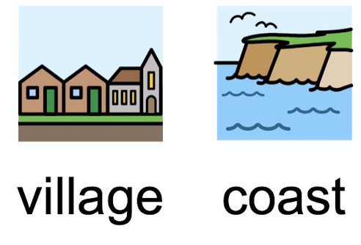  Summer 2 – History - Why is there an aircraft museum next to our school?  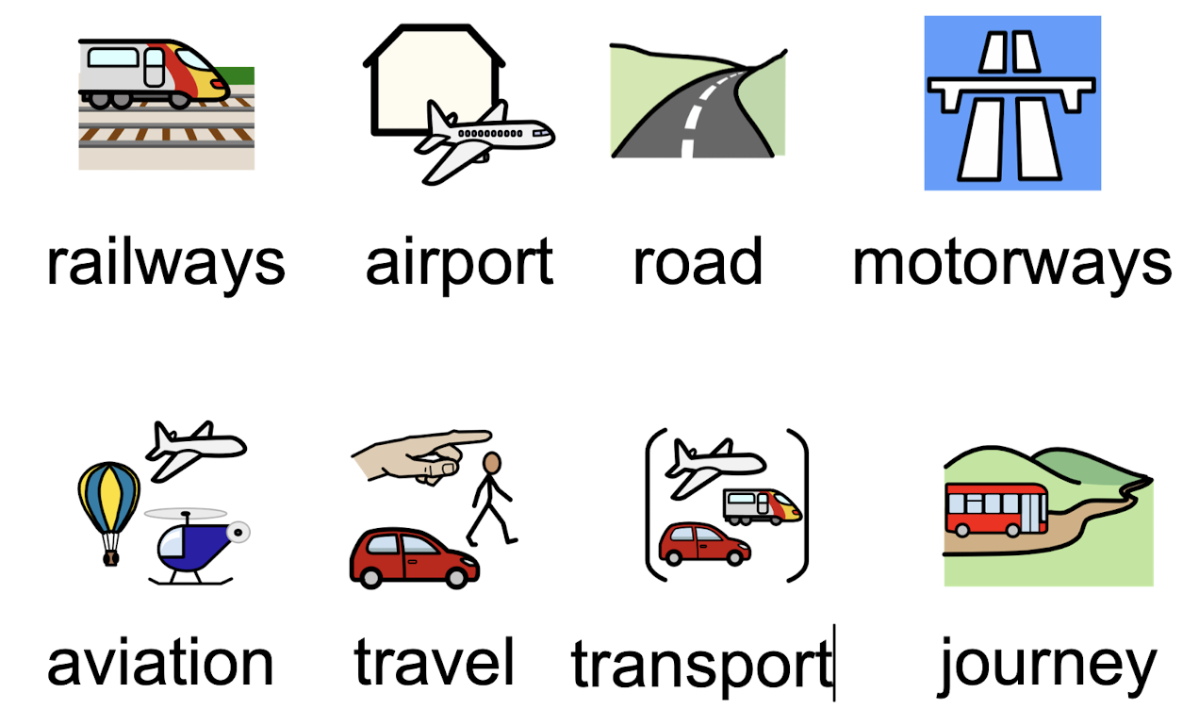 |  | MATHEMATICS
Writing  Core text: The Journey Home by Fran Preston-Gannon  Purpose: To entertain  Audience: School display  Other texts TBC. |  |  |  | White Rose Maths Programme  Block 1 – Number – Fractions  Block 2 – Measurement – Time  Block 3 – Statistics  Block 4 – Geometry – Position and Direction
Reading

Little Wandle reading sessions- 3x per week.
Whole class reading sessions- 2x per week.

Story time- 10 mins each day.
Regular Reading for Pleasure opportunities.

SPaG

Discreet SPaG sessions to be delivered as required.
SPaG teaching contextualised within writing lessons.
Little Wandle Spelling sessions – 5x week.

GEOGRAPHY |  | SCIENCE |  | RE
Over-riding theme: Features of coastal environments  - Where have you been for a coastal holiday in the UK? What are the human and physical features of a coastal town/Cleethorpes?  - What are the human and physical features of a coastal town in Madagascar? How do these compare to Cleethorpes?  - What is it like to live in a Madagascan village? |  | Summer 1 – Animals including Humans  NC objectives - Pupils should be taught to:  - notice that animals, including humans, have offspring which grow into adults  - find out about and describe the basic needs of animals, including humans, for survival (water, food and air)  - describe the importance for humans of exercise, eating the right amounts of different types of food, and hygiene.  Summer 2 – Plants  NC objectives - Pupils should be taught to:  - observe and describe how seeds and bulbs grow into mature plants  - find out and describe how plants need water, light and a suitable temperature to grow and stay healthy. |  | To Know You More Clearly Programme  Summer 1 - To the Ends of the Earth  Summer 2 – Dialogue and Encounter
HISTORY |  | ART and DESIGN TECHNOLOGY |  | PE
History of Transport  Enquiry question: Why is there an aircraft museum next to our school?  - Why is there an airport in Doncaster?  - How did people travel long distances before aeroplanes were invented?  - How do astronauts get to space? |  | Art  - Mixed media (collage) – coral reef inspired art piece  - Sculpture (paper mâché) – hot air balloon  Design technology  Twinkl Programme  - Sensational Salads |  | Get Set 4 P.E. Programme  Summer 1  - Striking and Fielding  - Sending and Receiving  Summer 2  - Athletics  - Ball skills
COMPUTING |  | PSHE / RSE |  | MUSIC
Teach Computing Programme  Summer 1 – Creating media – Digital music  Summer 2 – Programming B – Programming quizzes |  | TenTen Life to the Full Programme  Summer 1 - KS1 Module 1 Unit 4 AND KS1, Module 2, Unit 3  Summer 2 - KS1, Module 3, Unit 1 AND KS1, Module 3, Unit 2 |  | Charanga Programme  Summer 1  - Friendship song  Summer 2  - Reflect, rewind and replay

